* *Keen learner with constant zest to acquire new skills.*
* *Strong analytical problem solving and organizational abilities.*
* *Excellent writtenJ communication interpersonal liaison and problem solving skills with the ability to work in corporate environment.*
* *Tolerant and flexible to different situations.*
* *Organizational skills and customer service orientation.*
* *Adaptability and ability to work under pressure*

# EDUCATIONAL CREDEN TIALS

B. Tech Information Technology in 2014 with CGPA 79 %. Higher Secondary Education in 2010 with 72 %. Matriculation in 2008 Completed with 79 %.

# EXPERIENCE

* *Experience*
* *Position*
* *Department*
* *01ganization*

:1 Year

: Technical support Enginee� Smart class co-ordinator.

:IT{22/12/2014 -13/01/2016}

:Hinduja Global Solutions LtdJ India

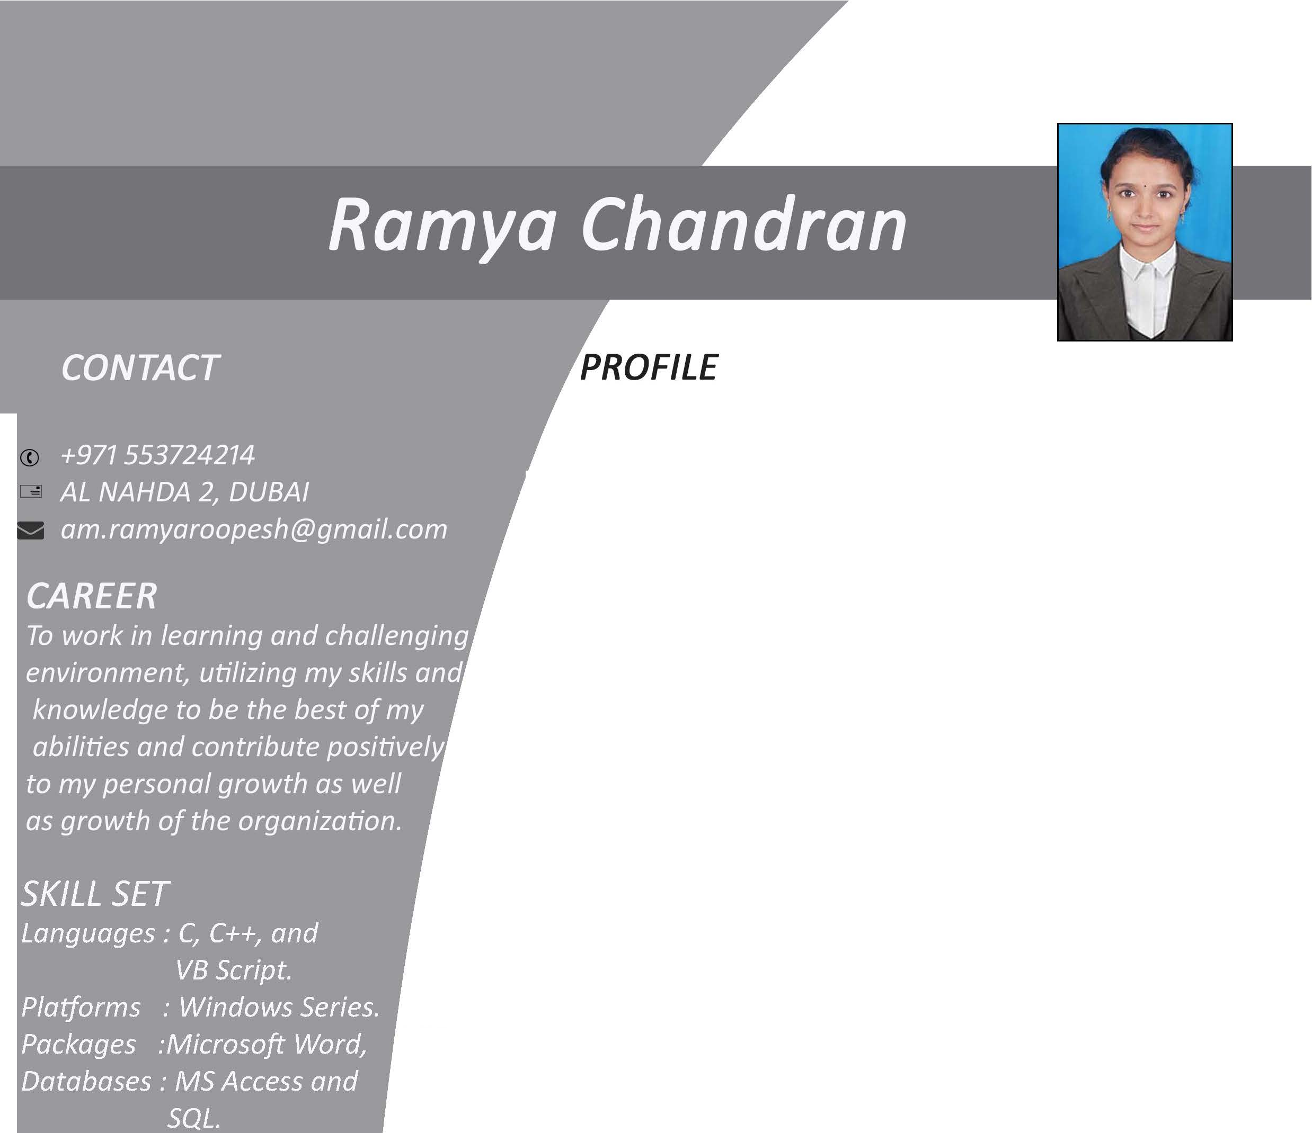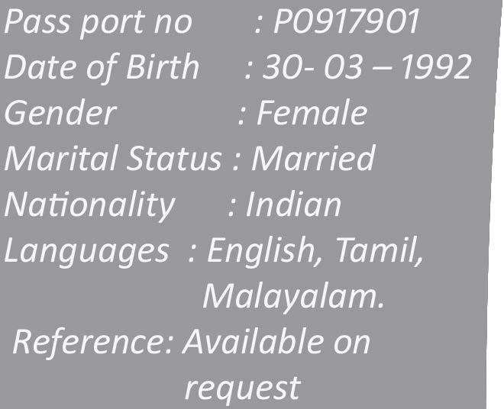

# DU TIES AND RESPONSIBILITIES

* On-site and remote technical support service.
* *Answer end user calls to assist them with software and equipment issue*
* *Provide remote assistance to users.*
* *Provide training to the client when the new software comes out.*
* *Provide investigationJ diagnosisJ resolution and recovery for*

software problemsJwhen unable to resolveJ escalate to second or third level in accordance with escalation process.

# DECLARATION

I hereby declare that the above mentioned information is correct up to my knowledge and I bear the responsibility for the correctness of the above mentioned particulars.

SIGNATURE